

WALCHAND COLLEGE OF ENGINEERING, SANGLI

**ELESA**

**ELECTRONICS ENGINEERING STUDENTS’ ASSOCIATION**

e-Yantra Practice Test-1

Email: [walchand.elesa@gmail.com](mailto:walchand.elesa@gmail.com) Website: [www.elesa.co.in](http://www.elesa.co.in)

Name:

Class:

1. Mark the wrong about Multivibrator?
2. Bistable has two state.
3. Monostable has two stable state.
4. Astable multivibrator will always be in stable state.
5. All options are wrong.

1. Which resistive component is designed to be temperature sensitive?

A) Thermistor

B) Rheostat

C) Potentiometer

D) Photoconductive cell

1. What is approximate peak to peak voltage of 0.5Vrms Sine wave?
2. 0.7 Vpp
3. ½ Vpp
4. 1.4 Vpp
5. 4 Vpp
6. Which of the following is not valid characteristic of an Ideal Opamp?
7. Zero output impedence
8. Infinite input offset voltage
9. Infinite input impedence
10. Infinite bandwidth
11. Dual slope converter is?
12. DC Converter
13. D/A Converter
14. A/D Converter
15. AC Converter
16. A 65 W Lamp in series with a room heater is connected across the mains. Which of the following will increase the heaters output?
17. Change 65W bulb with 120W bulb.
18. Change 65W bulb with 20W bulb.
19. Connect a bulb of 65 W in parallel.
20. Heater output will remain consant.
21. When two input of J-K flip flop are connected together it becomes___________ flip flop?
22. T
23. C
24. S-R
25. D
26. A Boolean Function f of two variable X and Y is defined as follows: f(0, 0) = f(1, 1) = 1; f(0, 1) = 0 Assuming components of X and Y are not available, a minimum cost solution for realizing using only NOR gate and OR gate (Each having Unit cost) would have total cost of?
27. 4
28. 1
29. 2
30. 3
31. What will be the gain of following Opamp?

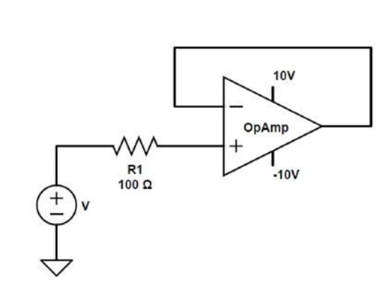

1. 0
2. 1
3. 10
4. 100
5. If the doping level of a crystal diode is increased, the breakdown voltage………….
6. remains the same
7. is increased
8. is decreased
9. none of the above



WALCHAND COLLEGE OF ENGINEERING, SANGLI

**ELESA**

**ELECTRONICS ENGINEERING STUDENTS’ ASSOCIATION**

e-Yantra Practice Test-2

Email: [walchand.elesa@gmail.com](mailto:walchand.elesa@gmail.com) Website: [www.elesa.co.in](http://www.elesa.co.in)

Name:

Class:

1. Refer to this figure. If the load current increases, IR will ________ and IZ will ________.

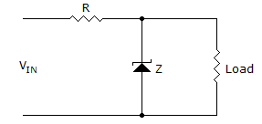

1. remain the same, increase
2. decrease, remain the same
3. increase, remain the same
4. remain the same, decrease
5. An S-R flip flop can be converted into T Flip flop by by connecting _________ to Qbar and _________ to Q?
6. S , R
7. R, S
8. R, Logic 1
9. None of the above
10. A transistor connected in Common base configuration has
11. High input resistance and low output resistance.
12. Low input resistance and High Output resistance
13. A low input resistance and low output reistance
14. High input resistace and high output resistance
15. An ideal voltage source should have
16. large value of e.m.f.
17. small value of e.m.f.
18. zero source resistance
19. infinite source resistance
20. When transistors are used in digital circuits they usually operate in the:
21. saturation and cutoff regions
22. linear region
23. active region
24. breakdown region

1. Op-amps used as high- and low-pass filter circuits employ which configuration?
2. Noninverting
3. Comparator
4. open-loop
5. inverting
6. A(A + B) = ?
7. AB
8. 1
9. (1 + AB)
10. A
11. What is the instantaneous peak voltage at 250° on a 6 V peak sine wave?
12. +5.64 V
13. –5.64 V
14. +26.13 V
15. –26.13 V
16. If the reactive power of a circuit is 50 mW while the apparent power is 64 mW, then what is the true power of the circuit?
17. 14 mW
18. 36 mW
19. 40 mW
20. 114 mW
21. What is true about the breakdown voltage in a Zener diode?
22. It decreases when current increases.
23. It destroys the diode.
24. It equals the current times the resistance.
25. It is approximately constant.